

**Scotch College**

**Semester Two Examination, 2015**

**Question/Answer Booklet**

**YR 11**

**Mathematics Methods**

**Section Two:**

**Calculator Assumed**

**Teacher:**

**Name:**

**Time allowed for this section**

Reading time before commencing work: 10 minutes

Working time for this section: 100 minutes

**Material required/recommended for this section**

***To be provided by the supervisor***

This Question/Answer Booklet

Formula Sheet

***To be provided by the candidate***

Standard items: pens, pencils, pencil sharpener, eraser, correction fluid, ruler, highlighters

Special items: drawing instruments, templates, notes on two unfolded sheets of A4 paper, and up to three calculators satisfying the conditions set by the School Curriculum and Standards Authority for this examination.

**Important note to candidates**

No other items may be taken into the examination room. It is **your** responsibility to ensure that you do not have any unauthorised notes or other items of a non-personal nature in the examination room. If you have any unauthorised material with you, hand it to the supervisor **before** reading any further.

**Structure of this paper**

|  |  |  |  |  |
| --- | --- | --- | --- | --- |
| Section | Number of questions available | Number of questions to be answered | Working time (minutes) | Marks  available |
| Section One:  Calculator-free | 9 | 9 | 50 | 50 |
| Section Two  Calculator-assumed | 13 | 13 | 100 | 100 |
|  |  |  |  | 150 |

**Instructions to candidates**

1. The rules for the conduct of Western Australian external examinations are detailed in the *Year 12 Information Handbook 2015*. Sitting this examination implies that you agree to abide by these rules.

2. Write your answers in the spaces provided in this Question/Answer Booklet. Spare pages are included at the end of this booklet. They can be used for planning your responses and/or as additional space if required to continue an answer.

* + Planning: If you use the spare pages for planning, indicate this clearly at the top of the page.
  + Continuing an answer: If you need to use the space to continue an answer, indicate in the original answer space where the answer is continued, i.e. give the page number. Fill in the number of the question(s) that you are continuing to answer at the top of the page.

3. **Show all your working clearly.** Your working should be in sufficient detail to allow your answers to be checked readily and for marks to be awarded for reasoning. Incorrect answers given without supporting reasoning cannot be allocated any marks. For any question or part question worth more than two marks, valid working or justification is required to receive full marks. If you repeat an answer to any question, ensure that you cancel the answer you do not wish to have marked.

4. It is recommended that you **do not use pencil** except in diagrams.

**Question 10** **(8 marks)**

Triangle *XYZ* is a triangle with Z (-1, -1) and Y (3, 1).

The equations of *XZ* and *XY* are  and  respectively.

Determine:

1. Solve the two equations simultaneously to determine the coordinates of the point *X*. (2 marks)
2. The equation of the line parallel to *XY* and passing through the

point (2,1).

(2 marks)

1. the equation of the line *YZ* algebraically. (2 marks)

**Question 11 (6 marks)**

Consider the function *g*(*x*) below, with turning point (*a*, *b*) and

*y* intercept (0, *c*).

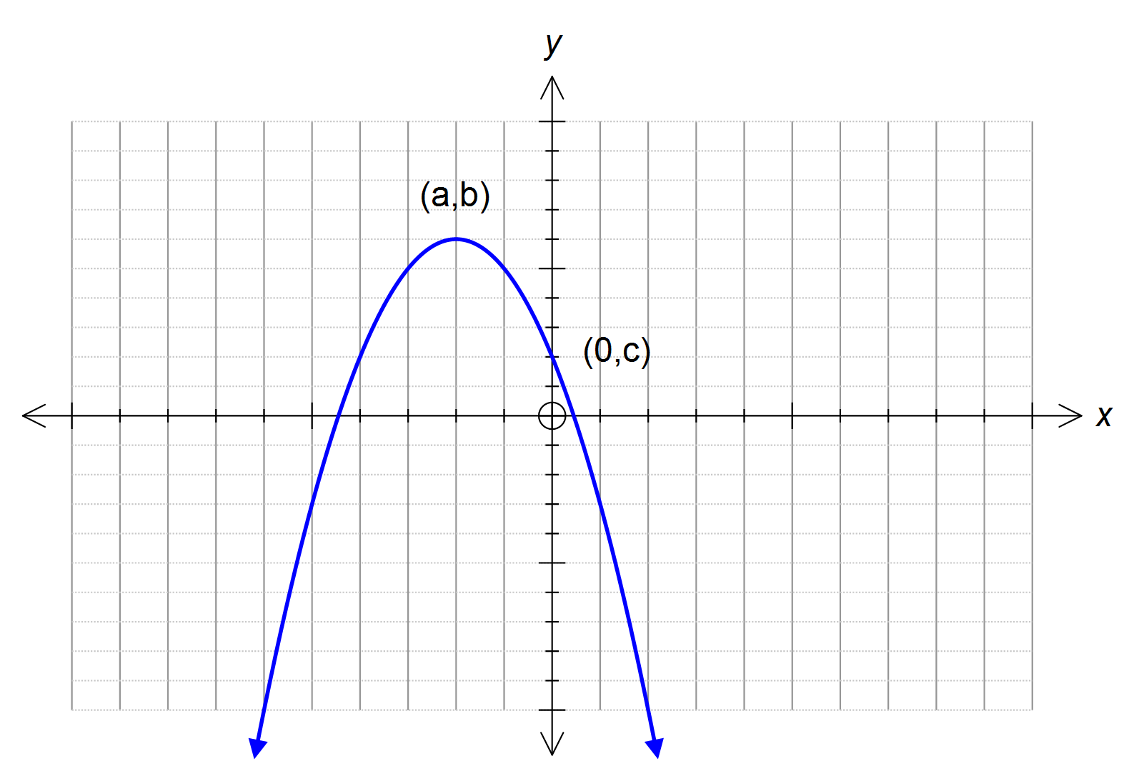

1. Determine the coordinates of the turning point for f(x),

if *f*(*x*) = *g*(*x* - 3) + 2 (2 marks)

1. Determine the coordinates of the y intercept for p(x),

if *p*(*x*) = - *g*(-*x* ) + 3 (2 marks)

1. State the domain and range of *m*(*x*), if *m*(*x*) = -*g*(*x* – 1).

(2 marks)

**Question 12** **(MAKE EASIER)**  **(5 marks)**

x + 1, 4x – 2, 10x + 4 are the third, fourth and fifth terms of a geometric sequence.

1. Determine the value(s) of x.

(3 marks)

1. Determine the first term.

(2 marks)

**Question 13** **(11 marks)**

A particle moves in a straight line so that its displacement, *x* metres from the

origin **0**, at any time, *t* minutes, is given by:



1. Determine :
   1. The initial displacement of the particle. (1 mark)
   2. The displacement when *t* = 15 seconds. (1 mark)
   3. The velocity function. (1 mark)
   4. When the particle first comes to rest. (2 marks)

1. The acceleration of another particle on the same straight line is . Initially this particle has a displacement of 30 metres and a velocity of 20 metres/minute.

* 1. Determine the velocity and displacement formulae for this particle. (4 marks)

(ii) When will the two particles have the same displacement?

(2 mark)

**Question 14** **(4 marks)**

Both of the following graphs have an equation in the form y = **a** cos **b**x.

State the values of **a** and **b** in both cases.

1. (2 marks)

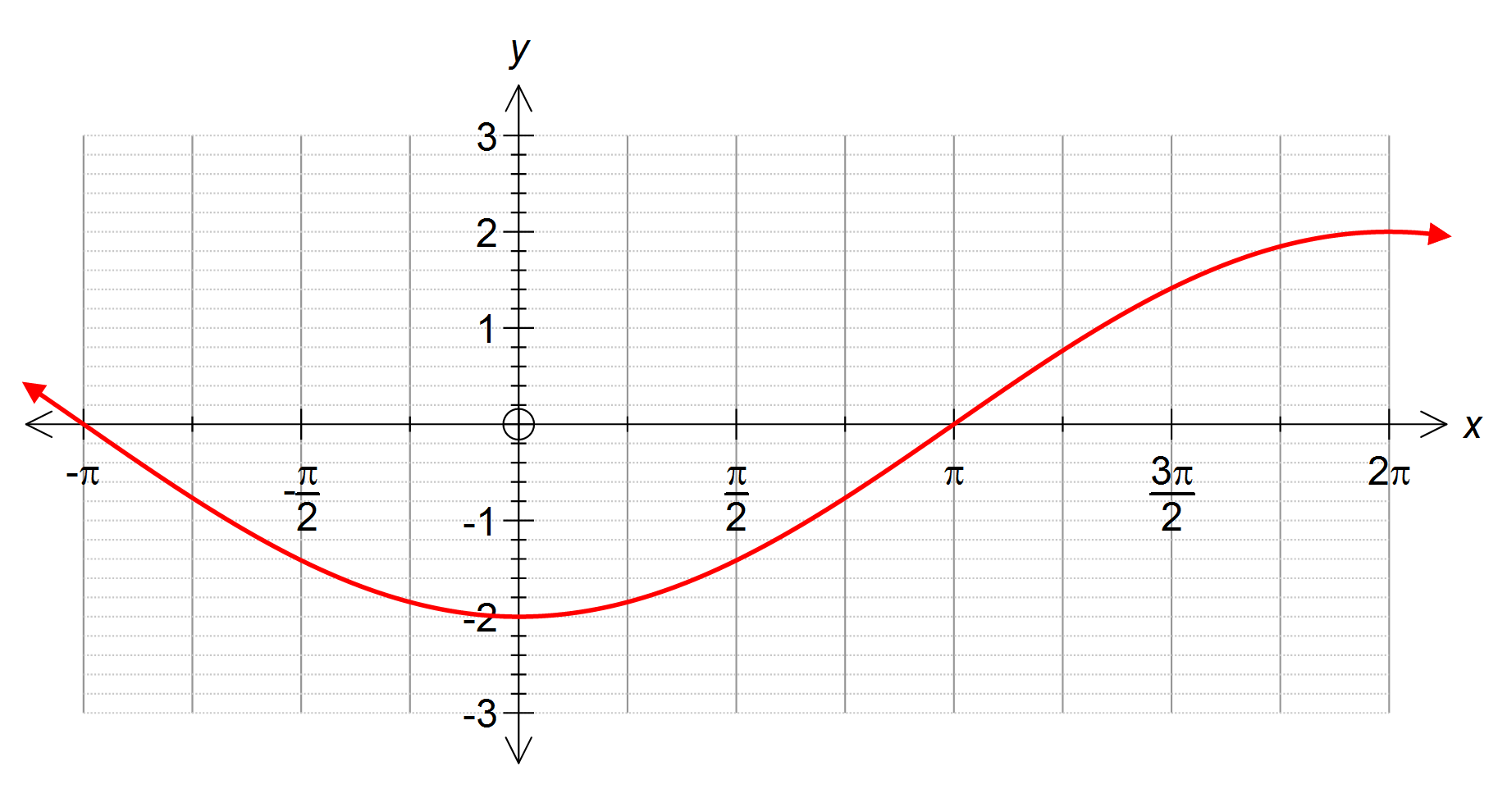



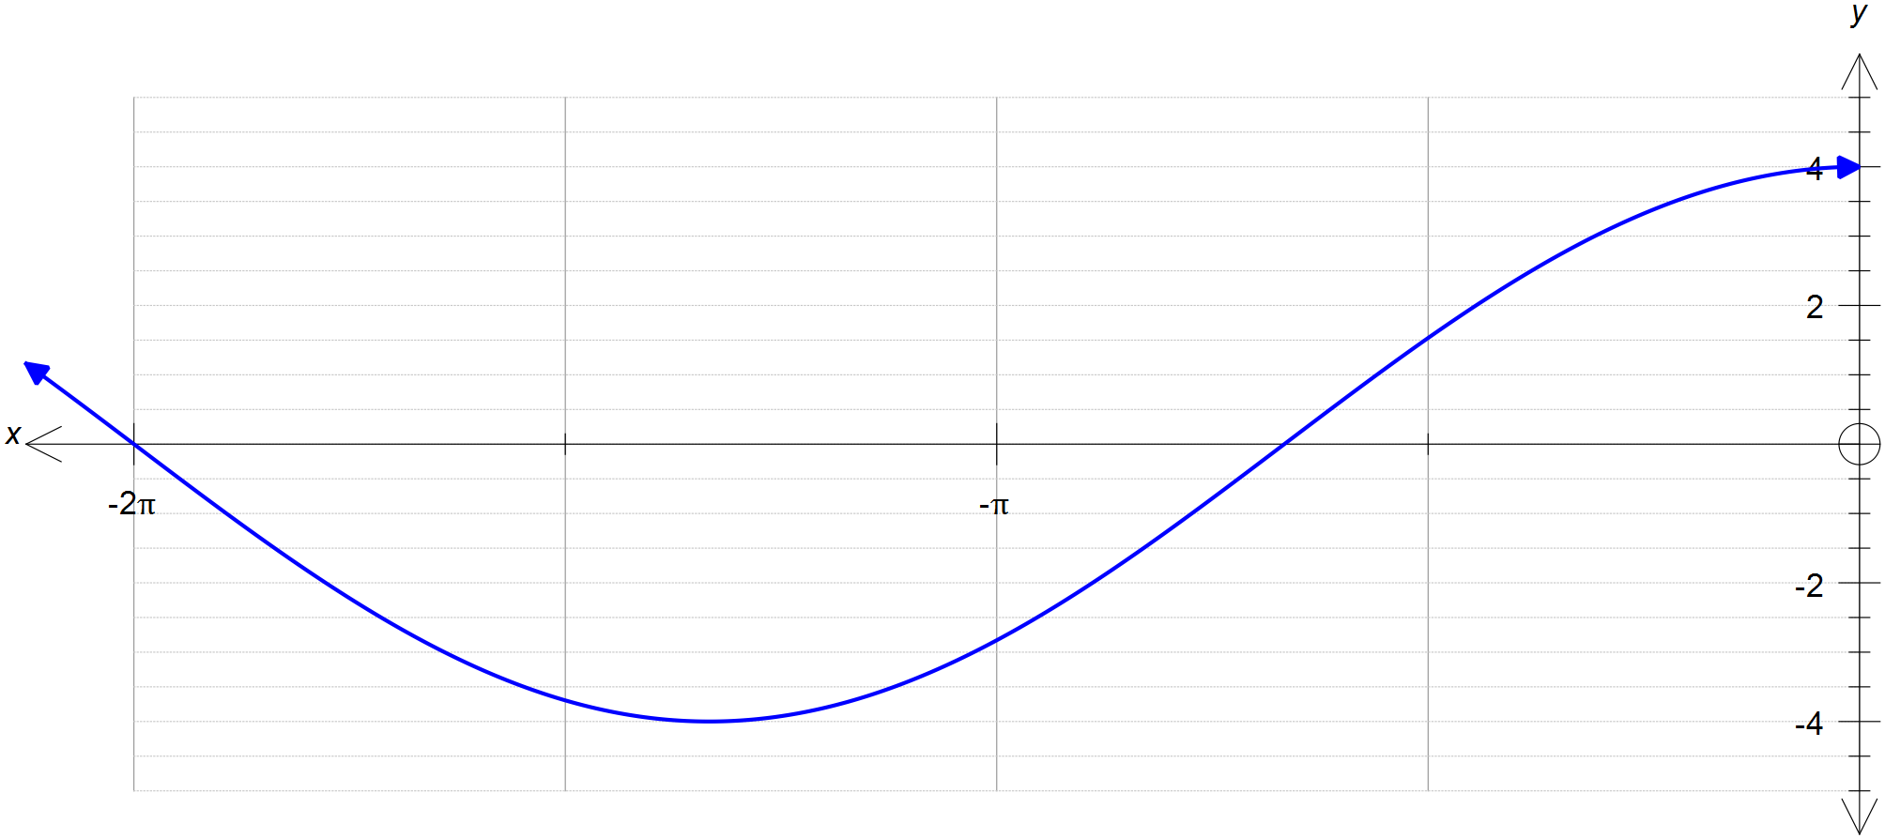

**Question 15** (MAKE EASIER) **(6 marks)**

The diagram below shows two overlapping circles. Determine the total area of the shaded areas in the diagram, given that and

O and C are the centres. The radius OA is 5cm and the radius CA is 7cm.

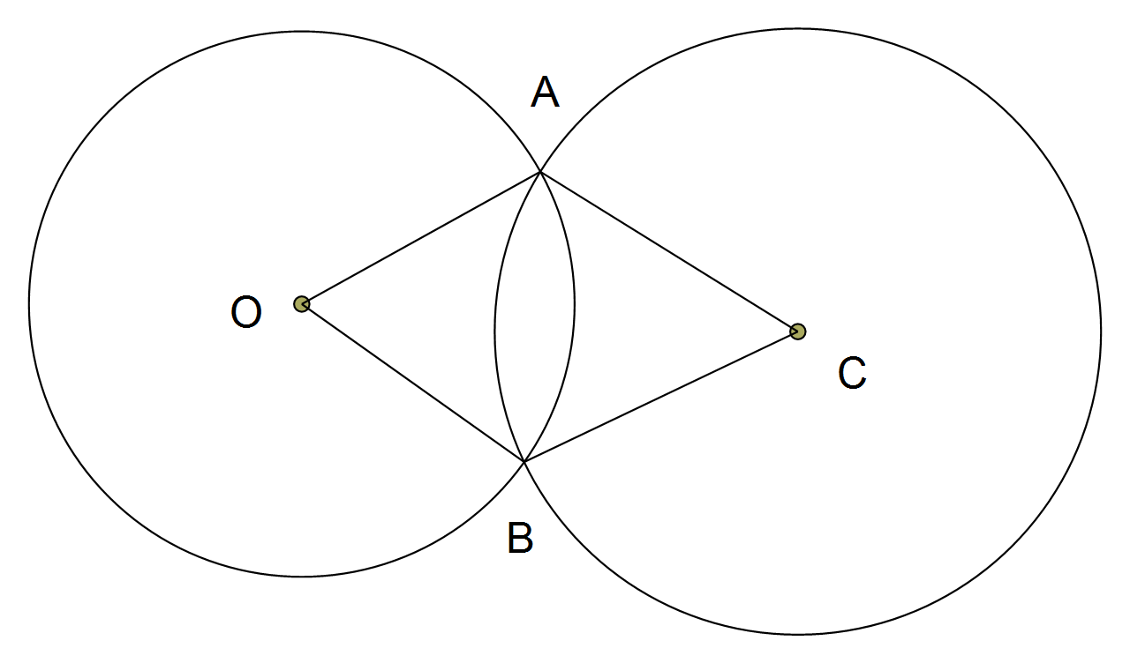

**Question 16** **(7 marks)**

Two events M and N are such that:

P(M) = 0.675 = 0.25 P(= 0.15

(a) Complete the Venn diagram below. (2 marks)

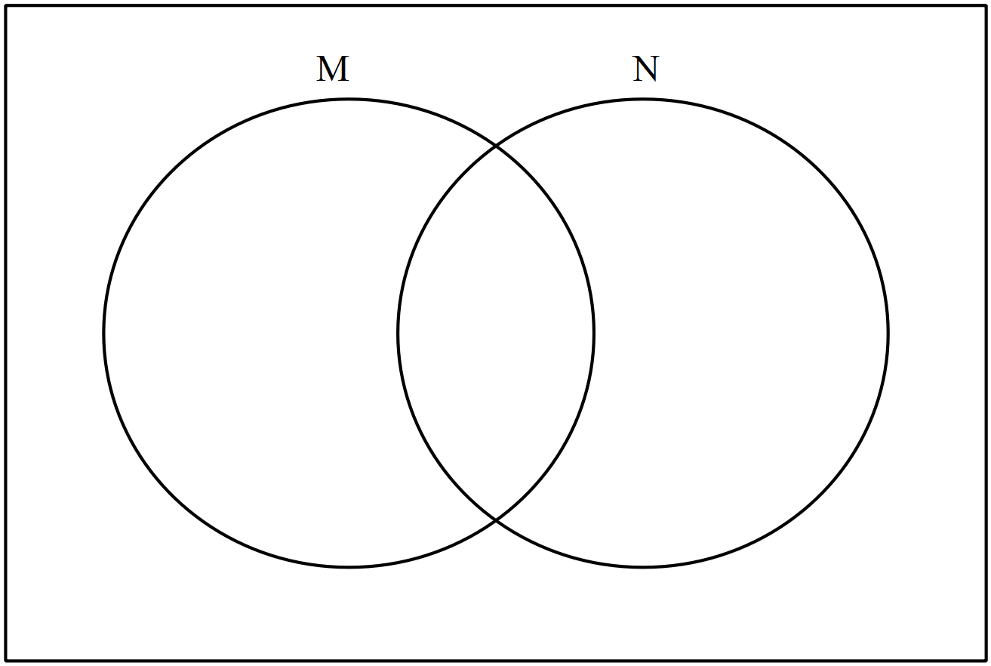

(b) Determine P() (1 mark)

(c) Determine P (| M). (1 mark)

(d) Are M and N mutually exclusive events? Justify your answer.

(1 mark)

(e) Are M and N independent events? Justify your answer.

(2 marks)**Question 17** **(10 marks)**

Given  where and  where 

Determine:

(a)  (2 marks)

(b)  (2 marks)

(c)  (3 marks)

(d) sin (A + B) (3 marks)

**Question 18** **(9 marks)**

The lines of a handball court are to be formed from tape.

The court must look like the diagram below where each small rectangle has the same dimensions.(i.e. *x* × *y*) There is 56 metres of tape available.

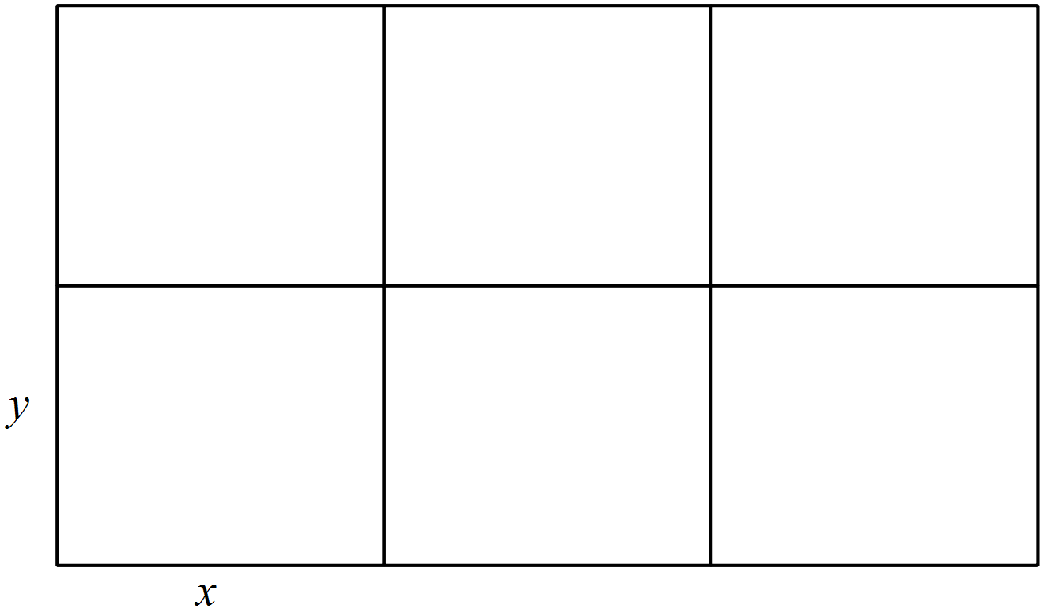

(a) Show that *y* = 7 – 1.125*x*. (2 marks)

(b) Show that the area,  (2 marks)

1. Using calculus techniques determine the length of *x* and *y* that will maximise the area of the handball court. What is the resulting area of the handball court. (5 marks)

**Question 19** **(14 marks)**

A function g(x) is given by:

g(x) = 24x + 3x2 – x3

(a) Find the x and y intercepts. (3 marks)

(b) Use calculus techniques, to determine the stationary points of g(x) and indicate their nature. (4 marks)

(c) Use your calculator to find the co-ordinates of the point(s) of inflection. (2 marks)

(d) Sketch g(x) on the axes provided below. (3 marks)

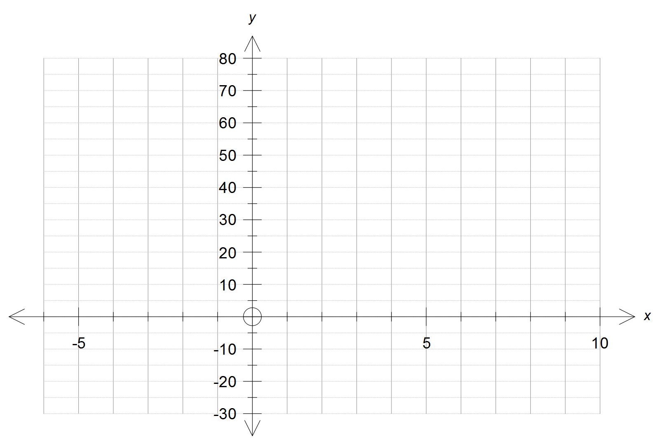

(e) State the intervals where g(x) is increasing. (2 marks)

**Question 20 (6 marks)**

* 1. Determine the centre and radius of the circle with equation

x2 + y2 -10x -16y = -36. (2 marks)

* 1. How many points of intersection does this circle have with the line

y = 2x - 4. (Working is expected) (4 marks)

**Question 21** **(6 marks)**

The number of a certain species of fish, in the North Atlantic Ocean, can be modelled by the function:

*n*(*t*) = 12 (1.005)*t*

Where *t* is the number of years and *n*(*t*) is the number in thousands.

(a) What is the % increase in fish each year? (1 mark)

(b) What is the fish population in 5 years? (1 mark)

(c) After how many years will the number of fish reach 30 thousand? (2 mark)

Another population of fish can be modelled by:

*m*(*t*) = 8 (1.035)*t*

Where *t* is the number of years and *m*(*t*) is measured in thousands.

1. Determine when the second species of fish will outnumber the first species. (2 marks)

**Question 22** **(8 marks)**

# A committee of three people is to be chosen from 4 men and 3 women. Alan is one of the 4 men and Betty is one of the 3 women.

(a) How many committees are possible? (1 mark)

(b) How many committees are possible that contain Alan or Betty or both?

(3 marks)

(c) A third person Jack is also one of the group. How many committees are possible that contain exactly one or two out of Alan, Betty and Jack?

(4 marks)

***Structure of this section***

|  |  |  |
| --- | --- | --- |
| **Question** | **Marks available** | **Marks obtained** |
| 10 | 8 |  |
| 11 | 6 |  |
| 12 | 5 |  |
| 13 | 11 |  |
| 14 | 4 |  |
| 15 | 6 |  |
| 16 | 7 |  |
| 17 | 10 |  |
| 18 | 9 |  |
| 19 | 14 |  |
| 20 | 6 |  |
| 21 | 6 |  |
| 22 | 8 |  |
| Total for this section | 100 |  |